**Abstract:**

*This study investigates the application of Recurrent Neural Networks (RNNs) for predicting stock prices in financial markets. RNNs, known for their ability to handle sequential data, have shown promise in capturing temporal dependencies inherent in stock price movements. This research explores the effectiveness of RNN architectures, including Long Short-Term Memory (LSTM) and Gated Recurrent Unit (GRU), in modelling stock price time series data. The study aims to evaluate the predictive capabilities of these models and assess their potential in assisting investors and financial analysts in making informed decisions.*

**Introduction:**

Predicting stock prices accurately has been a long-standing challenge in financial markets due to their inherent complexity, volatility, and sensitivity to various factors. Traditional statistical models often struggle to capture the intricate patterns and nonlinear relationships present in stock price movements. However, the advent of advanced machine learning techniques, particularly Recurrent Neural Networks (RNNs), has opened new avenues for tackling this intricate problem.

RNNs, a class of artificial neural networks designed to process sequential data, have shown promise in modeling and forecasting stock prices. The distinctive feature of RNNs lies in their ability to retain memory of past inputs through hidden states, allowing them to capture temporal dependencies present in sequential data. This makes them well-suited for analyzing historical stock price data, as stock markets exhibit clear temporal patterns influenced by various economic, financial, and market-specific factors.

One of the notable variants of RNNs, the Long Short-Term Memory (LSTM) network, addresses the challenge of capturing long-range dependencies. LSTMs employ gated cells that selectively retain or forget information over time, enabling them to capture and remember essential information from distant past inputs. Similarly, the Gated Recurrent Unit (GRU), another variant, simplifies the gating mechanism while maintaining the ability to learn temporal dependencies. This research aims to explore the efficacy of RNN-based models, including LSTM and GRU architectures, in predicting stock price movements. By leveraging historical stock market data, the study seeks to train and evaluate these neural network models to forecast future price movements within a certain time horizon.

The dataset used for this project comprises historical stock prices, including open, high, low, close prices, volume, and potentially additional technical indicators. These features are processed and fed into the RNN models, allowing them to learn patterns and relationships present in the historical data. The objective is to develop a robust predictive model that effectively learns from historical price patterns and generalizes well to unseen data. Evaluation metrics such as accuracy, precision, recall, and F1-score will be utilized to assess the model's performance in predicting stock price movements. The outcomes of this research Endeavor are expected to contribute insights into the feasibility and effectiveness of using RNN-based models in stock price prediction. If successful, these models could potentially aid investors, financial analysts, and decision-makers in making more informed investment decisions, managing risks, and navigating the complex dynamics of financial markets. Nonetheless, it's important to note that predicting stock prices remains inherently challenging due to the multitude of factors influencing market behaviour.

**RNN Architecture:**

In the domain of stock price prediction, Recurrent Neural Networks (RNNs) serve as a powerful tool due to their capacity to grasp sequential dependencies within historical stock market data. The architecture of an RNN tailored for stock prediction revolves around its ability to retain memory from past inputs while incorporating temporal dynamics into predictions. At the outset, the input data comprising historical stock prices, including features like Open, High, Low, Close prices, volume, and potentially derived technical indicators, undergoes preprocessing. Sequential data sequences are then constructed, defining historical sequences within a given time frame, establishing the sequential nature of the dataset. The choice of RNN architecture, such as Long Short-Term Memory (LSTM) or Gated Recurrent Unit (GRU), is pivotal. LSTMs incorporate memory cells, input gates, forget gates, and output gates, enabling them to capture long-range dependencies and mitigate the vanishing gradient problem. Conversely, GRUs, with simplified gating mechanisms, maintain computational efficiency while still capturing temporal patterns.

The network structure involves configuring the RNN model, specifying the number of layers, hidden units, and input/output dimensions. Stacking multiple layers of RNN cells enables the model to learn hierarchical representations of the sequential data, potentially improving its capacity to discern complex patterns. Training the RNN involves feeding the historical stock price sequences into the network. Through iterations, the model learns to predict future stock prices or price movements by adjusting its internal parameters using backpropagation through time (BPTT) and optimizing a chosen loss function, like Mean Squared Error. Hyperparameter tuning and regularization techniques are employed to enhance the model's performance and prevent overfitting. Experimentation with learning rates, batch sizes, and regularization methods is crucial for optimizing the model's accuracy and generalizability to unseen data. Upon completion of training, the RNN is used to make predictions on test data, evaluating its performance using metrics like accuracy, mean squared error, or directional accuracy. Iterative improvements involve fine-tuning the architecture, adjusting hyperparameters, and potentially incorporating additional relevant features to refine the model's predictive capabilities, aiming for accurate and reliable stock price predictions.

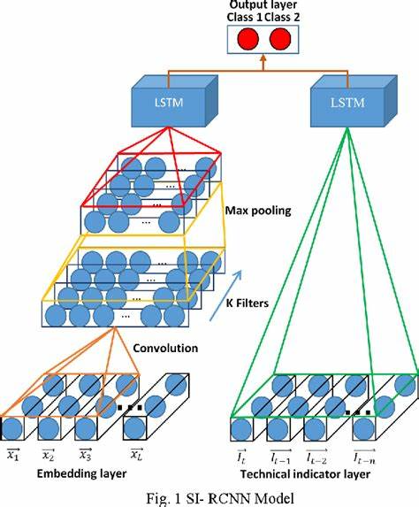

**LSTM & GRU:**

Long Short-Term Memory (LSTM) and Gated Recurrent Unit (GRU) are sophisticated variants of Recurrent Neural Networks (RNNs), engineered to overcome the limitations of standard RNNs in effectively capturing long-term dependencies within sequential data while addressing the vanishing gradient problem. These specialized architectures have garnered significant attention and found widespread use across diverse fields due to their ability to model sequential information.

LSTM, a more complex architecture, boasts an intricate memory cell design that enables the network to retain and selectively store information over extended sequences. Central to LSTM's functionality are its three distinct gates: the input gate, forget gate, and output gate. The input gate regulates the inflow of new information into the memory cell, while the forget gate manages the retention or removal of data from the cell. Simultaneously, the output gate controls the output of information from the memory cell to subsequent steps in the sequence. These gates empower LSTMs to remember and utilize information over prolonged intervals, making them adept at capturing both short-term and long-term dependencies within sequential data, showcasing superior performance in tasks requiring prolonged memory, such as speech recognition, language translation, and time-series analysis.

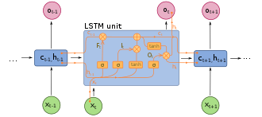

On the other hand, GRUs present a more streamlined architecture compared to LSTMs, integrating fewer parameters and a reduced number of gates. GRUs amalgamate the functionality of the input and forget gates in LSTMs into a single update gate. Additionally, GRUs encompass a reset gate that modulates the extent of memory resetting or forgetting. This simplified design allows GRUs to capture long-term dependencies in sequences while offering computational efficiency. Despite their relative simplicity compared to LSTMs, GRUs have demonstrated competitive performance in various applications involving sequential data, showcasing effectiveness in tasks such as machine translation, video analysis, and sentiment analysis.

**Implementation of RNN:**

Implementing a Recurrent Neural Network (RNN) for sequence prediction involves several key steps, from setting up the architecture to training the model and making predictions. The design of an RNN typically involves selecting an appropriate architecture such as Long Short-Term Memory (LSTM) or Gated Recurrent Unit (GRU), which are specialized variants of RNNs capable of capturing long-range dependencies in sequential data. These architectures address the challenge of retaining information over time, crucial for tasks like stock price prediction. An RNN comprises input nodes representing sequential data, hidden layers (LSTM/GRU cells), and an output layer for predictions.

Preparing the data is crucial. Sequential data, such as historical stock prices, needs to be structured into input sequences and corresponding output values. This involves splitting the data into training, validation, and test sets. Additionally, data preprocessing techniques like normalization, handling missing values, and feature engineering may be employed to improve model performance. Training an RNN involves feeding sequential data into the network. During training, the RNN learns to capture patterns and dependencies in the historical stock price data. The model iteratively adjusts its internal parameters (weights and biases) using optimization algorithms like gradient descent, minimizing a chosen loss function (e.g., Mean Squared Error for regression tasks). The aim is to make accurate predictions of future stock prices based on historical patterns learned from the training data.

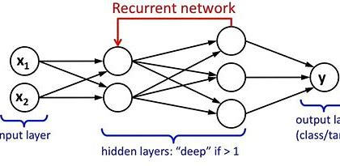

After training, the RNN's performance is evaluated using a separate validation dataset to assess how well it generalizes to unseen data. Metrics such as accuracy, mean squared error, or directional accuracy for predicting stock price movements are used to evaluate the model's performance. Visualization of training and validation loss over epochs helps analyze the model's learning behaviour and potential overfitting. Once the model is trained and validated, it is deployed to make predictions on new, unseen data. The RNN utilizes the learned patterns and dependencies from historical data to predict future stock prices or price movements within a certain time horizon. These predictions can assist investors and analysts in making informed decisions in the dynamic landscape of financial markets.

**Code Explanation:**

Data Loading and Visualization

- Imports necessary libraries such as NumPy, Pandas, Matplotlib, TensorFlow, etc.

- Loads a stock price dataset from a CSV file.

- Normalizes the data and visualizes the stock prices and volumes using Matplotlib.

Data Preprocessing:

- Defines functions to normalize the data and create sequences of data for training the model.

- Splits the dataset into training, validation, and test sets.

TensorFlow Model Building:

- Implements a basic RNN (Recurrent Neural Network) using TensorFlow for stock price prediction.

- Defines placeholders, RNN cell types (RNN, LSTM, GRU), layers, loss function, optimizer, and training operation.

Training the Model:

- Runs the TensorFlow graph and trains the model using training data.

- Prints Mean Squared Error (MSE) for training and validation sets during training iterations.

Model Prediction and Evaluation:

- Uses the trained model to predict stock prices for training, validation, and test sets.

- Plots the predicted stock prices against the actual stock prices for visualization.

- Computes the percentage of correct predictions regarding the direction (increase/decrease) of stock prices (close - open) for training, validation, and test sets.

**Conclusion:**

Recurrent Neural Networks (RNNs) have emerged as powerful tools in predicting stock prices due to their ability to capture sequential dependencies in time-series data. They excel in learning patterns and relationships from historical stock data, allowing them to make informed predictions about future price movements. RNNs, with variants like Long Short-Term Memory (LSTM) or Gated Recurrent Unit (GRU), have shown promise in modeling the non-linear and complex nature of financial markets.

However, predicting stock prices remains an inherently challenging task due to market unpredictability, influenced by multifaceted factors such as economic indicators, geopolitical events, and investor sentiments. While RNNs demonstrate proficiency in learning temporal patterns, their performance can be affected by the noise inherent in financial markets and sudden shifts in trends that might deviate from learned patterns. Solely relying on historical price data for predictions might overlook other essential market features and external influences that contribute to price fluctuations. Incorporating additional data sources and employing robust feature engineering techniques alongside RNNs could enhance their predictive capabilities.

In conclusion, while RNNs present a promising approach for stock price prediction by leveraging sequential dependencies in data, their efficacy in real-world applications depends on addressing challenges related to market noise, incorporating diverse data sources, and adapting to rapidly changing market conditions for more accurate and reliable predictions.

**Summary:**

Recurrent Neural Networks (RNNs) utilize sequential data to predict stock prices. By capturing temporal dependencies, RNNs process historical stock data and learn patterns for future predictions. They employ memory cells to retain past information, enabling analysis of time-series data for forecasting. RNNs' ability to understand sequential patterns makes them suitable for predicting stock prices, although their accuracy depends on data quality, model architecture, and market volatility. Despite challenges like volatility and complex market behaviour, RNNs leverage sequential information to forecast stock prices, contributing to financial decision-making and market analysis.

**References:**

1. Medsker, L.R. and Jain, L.C., 2001. Recurrent neural networks. *Design and Applications*, 5(64-67), p.2.
2. Grossberg, S., 2013. Recurrent neuralnetworks *Scholarpedia*, 8(2), p.1888.
3. Salehinejad, H., Sankar, S., Barfett, J., Colak, E. and Valaee, S., 2017. Recent advances in recurrent neural networks. *arXiv preprint arXiv:1801.01078.*
4. Yu, Y., Si, X., Hu, C. and Zhang, J., 2019. A review of recurrent neural networks: LSTM cells and network architectures. *Neural computation*, 31(7), pp.1235-1270
5. Zaremba, W., Sutskever, I. and Vinyals, O., 2014. Recurrent neural network regulation
6. Rather, A.M., Agarwal, A., and Sastry, V.N., 2015. Recurrent neural network and a hybrid model for prediction of stock returns. *system with applications,*42(6), pp.3234-3241.